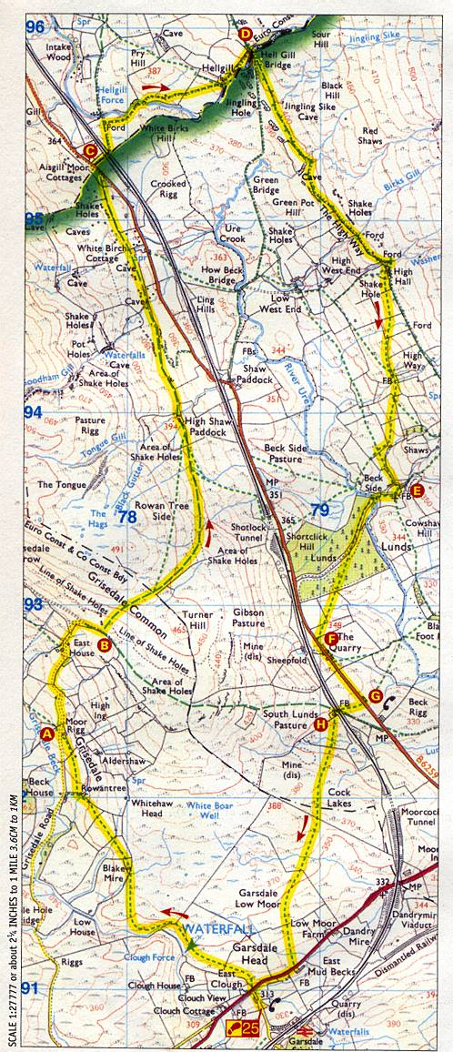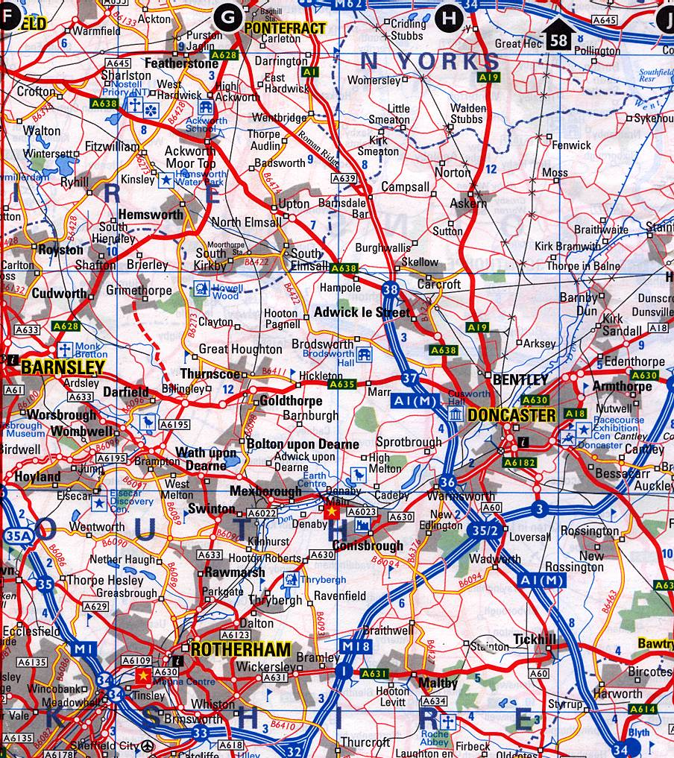
SCALE 1:200000
Hemsworth and surrounding districts

SCALE 1:25000 Garsdale Head, Yorkshire Dales
MAP SCALES
1) Copy and complete the table about the first map, part of the Yorkshire Dales.
Scale 1:25000
Distance on map | Actual distance (cm) | Actual distance (m) | Actual distance (km)
1cm
3cm
10cm
7.5cm
2 a) What is the distance on the map between Garsdale (bottom) and Black Hill (Top right)?
b) Find the actual distance in km between Garsdale and Black Hill.
3) Copy and complete the table about the first map.
From | To | Distance on map (cm) | Actual distance (km)
A | E
C | H
D | A
F | G
4) There is a railway line on the map.
Use string to estimate the actual distance along the railway line from Shotlock tunnel to Garsdale. Give your answer in km.
5) You travelled by road from C to G. Estimate how far would you travel in km.
6a) The yellow route on the map represents a hike. Estimate the length of the walk in km?
b) How far is this in miles? (5miles = 8 km)

1) Copy and complete the table about the second map around Hemsworth.
Scale 1:200000
Distance on map | Actual distance (cm) | Actual distance (m) | Actual distance (km)
1cm
5cm
10cm
6.5cm
2a) How far apart is the centre of Pontefract from the centre of Doncaster in km? The centre is shown by a small square.
b) How many miles is this?
3) There is going to be a school trip from Hemsworth to Doncaster Racecourse Exhibition Centre. We are to go via Great Houghton, A635, A1M.
a) Use string to estimate the actual distance in km and miles.
b) Can you find a shorter route?
4) Copy and complete the table about the second map.
From | To | Dist. by road on map (cm) | Actual dist. by road (km)
Hemsworth | Pontefract
Hemsworth | Barnsley
Pontefract | Rotherham
Crofton | Conisbrough Castle

